/root/AndySpace/dwave

连接QPU:

1、进入python的虚拟环境：source ocean/bin/activate 退出虚拟环境： deactivate

连接QPU的参数设置：（具体操作：https://www.youtube.com/watch?v=4L7fMdBMqVU）

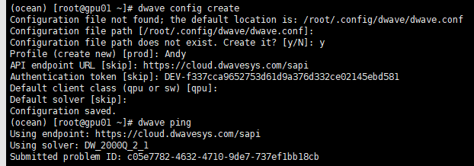

2、连接QPU: dwave config create (GPU上连接QPU为本人的账号)

dwave config inspect

**Solving Problems on a D-Wave System：**

1. Formulate the problem as a binary quadratic model (BQM)
2. Solve the BQM with a D-wave system or classical sampler.

Qubit bias weights: control the degree to which a qubit tends to a particular state.

Qubit coupling strengths: control the degree to which two qubits tend to the same state.

Ocean’s **dimod** provides a sampler that simply returns the BQM’s value for every possible assignment of variable values.

dwave_networkx.generators.chimera_graph()

https://docs.ocean.dwavesys.com/projects/dwave-networkx/en/latest/reference/generated/dwave_networkx.generators.chimera_graph.html#dwave_networkx.generators.chimera_graph

